Project Vision & Problem Statement

The Strategic Problem: The Sarcasm Gap

The "Sarcasm Gap" represents a critical failure point in modern e-commerce sentiment analysis. While traditional models identify obvious polarized words, they frequently falter when encounter- ing "Ironic Dissonance" - a phenomenon where the semantic content of a review contradicts its intended sentiment.
Standard "Bag-of-Words" models (Logistic Regression, Random Forest) are fundamentally limited by their reliance on keyword frequency and ignore bidirectional relationship and negative modifiers (e.g., weighting "perfectly" as positive even when followed by "mis-crafted"). When sarcasm is misclassified, business intelligence is compromised, leading to skewed data that mask severe product defects.

Core Objectives
    - Solve the Sarcasm Gap: Move beyond keyword matching to understanding bidirectional sequence context.
    - Neural Normalization: Automatically "clean" and "rewrite" messy, slang-heavy user reviews before classification using generative models (LQN).
    - Agentic Reasoning: Provide human-readable explanations ("Why") for every prediction to improve transparency and trust.
    - Hardware Democratization: Ensure that the system runs efficiently on consumer-grade hardware (8GB RAM / CPU-only) without requiring GPUs.

Literature Survey & Gap Analysis

2.1. Comprehensive Literature Survey

The following table provides a systematic review of the literature from 2021 to 2026, mapping contemporary research against the Sentiment Intelligence System.

Author & Year
Table 2.1.: Comprehensive Literature Survey

Title Contributions Literature Gap Project Fix

Maragheh et al. (2025)

Cao & Hu (2026)

Ayanami0730 (2026)

Scott et al. (2025)

Wen & Reza- pour (2026)

Daraghmi
& Zyadeh (2026)
Thogesan et al. (2025)

Dubey et al. (2025)
ARAG: Agen- tic RAG

Solicit-Then- Suggest Agen- tic Purchasing
A-RAG: Scal-
ing Agentic RAG

ABSA on Ama- zon Reviews

Transformer
& Prototype Model

Sentiment Classification study
XAI with LLMs

Unpacking Sar- casm
Multi-agent collabora-
tion in RAG pipelines.
Multi-round conversations for preference.
Hierarchical tools for agent autonomy.

Novel Hybrid ML Algorithm (SVHA).
Prototype tensors for sentence-level XAI.
Benchmarks ML and DL models.
Layer-wise SHAP analysis for BERT.
Contextual Transformer Approach.
Fails to capture nu- anced preferences.

Lacks ability to learn from messy descriptions.
Rigid RAG systems without model par- ticipation.

struggles with com- plex language struc- ture.
Word-level XAI is non-intuitive for irony.

Fails to capture sar- casm and negation.

LLMs function as "black boxes".

Lack of structured preprocessing.
Multi-Tiered Agen- tic Architecture.

LQN to program- matically repair de- scriptions.
Intelligence pipeline (Nor- malize → Analyze
→ Explain).
Sublinear TF-IDF and neural normal- ization.
RE providing symbolic "Conflict Logic".

Contextual Per- sistence in Distil- RoBERTa.
RE mapping confi- dence to insights.

Latency reduction 16s to 1.1s via prun- ing.

Author & Year
Title Contributions Literature Gap Project Fix

Akter et al. (2025)

Agrawal (2025)

Trivedi (2025)

Chauhan
& Kumar (2024)
Kaseb & Farouk (2023)
Abu Farha et al. (2022)

Romio, G. (2026)
Sentiment Analysis Im- pact
Future of E- Commerce AI

Explainable Agentic AI

Multilingual Sarcasm

SAIDS: Dialect and Sarcasm

Sarcasm Detec- tion easy?

15 Best AI SA Tools
Validates BERT outper- forms ML.
Specialized agents for life domains.
Conceptual models for agentic search.
mBERT for code-mixed text.
Informed decision archi- tecture.
Benchmarks human vs machine.
Reviews top- tier platforms for 2026.
High computa-
tional resource demands.
Lacks goal-oriented understanding.

Transparency issues in autonomy.

Emojis and slang degrade accuracy.

Literal vs Intended meaning conflict.

Machine models struggle with context.
Basic keyword matching false alarms.
Hardware Democ- ratization (8GB RAM/CPU).
End-to-end reason- ing pipeline.

RE providing ver- ifiable reasoning trace.
Emoji Demojiza- tion and custom slang map.
Active Mining of Ironic Dissonance.

Specialist Engine trained on "Hard Cases".
RE flags "Conflict of Signals".

Research Methodology & Timeline

The Modified CRISP-DM Approach

We followed a 6-phase scientific approach to ensure data integrity:

Phase 1
Problem Definition & Data Selection (Amazon, Flipkart, PUMA).

Phase 2
Data Refinery & Feature Engineering (Regex cleaning, Lemmatization).

Phase 3
Baseline Modeling (LR, RF, XGBoost).

Phase 4
Synthesis & Deep Intelligence (BERT/RoBERTa).

Phase 5
Implementation & Visual Analytics (FastAPI, Streamlit).

Phase 6
Final Evaluation & Documentation.

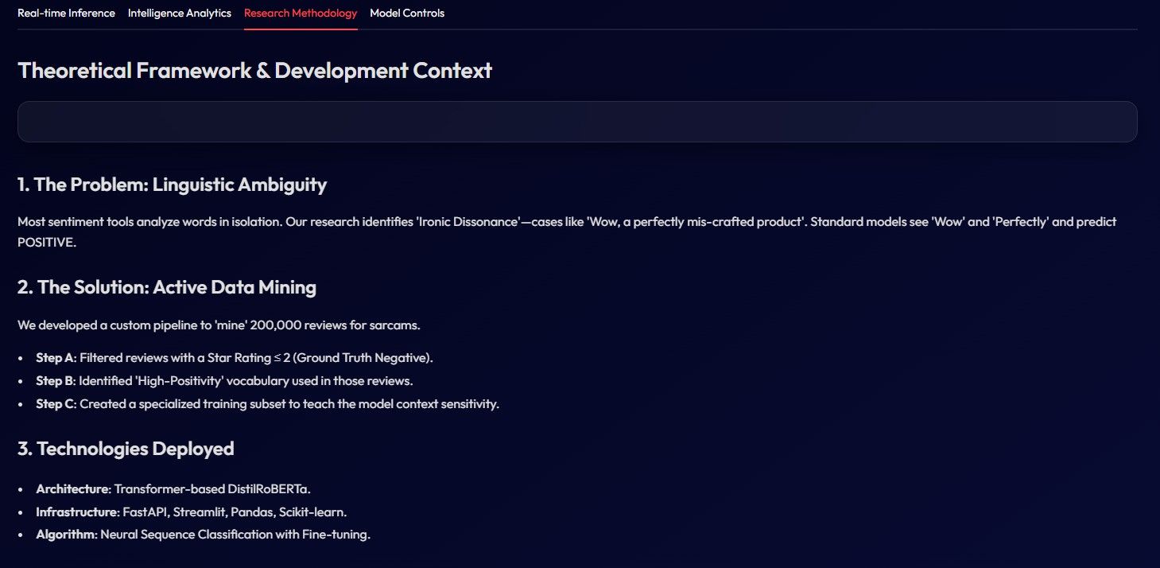
0-1 SINE Research Methodology: From Problem Definition to Final Evaluation.

The 10-Week Evolution

The project followed a rigorous 10-week development cycle, evolving from a standard statistical classifier into a sophisticated neural agent.

Weeks 1–2: Initiation & Diagnostic
Analyzed 200k+ rows; identified heavy imbalance. Resolved scikit-learn and XGBoost
mismatches that caused crashes during high-dimensional matrix operations.

Weeks 3–4: Data Refinery & Classical Modeling
Trained RF and XGBoost. Reached 84% accuracy but confirmed systematic sarcasm failure. Applied SMOTE to address Neutral class deficiency.

Weeks 5–6: The Context Revolution
Pivoted to Transformers. Discovered "Neural Echoing" in T5 models where models repeated input instead of repairing it.

Weeks 7–8: Agentic System Development
Architected the LQN and RE; designed the professional, emoji-free Glassmorphism Dash- board.

Weeks 9–10: Specialist Optimization & Final Polish
Engineered the Ironic Dissonance Miner; fine-tuned DistilRoBERTa Specialist; reduced latency from 16.7s to 1.1s.

Data Refinery & Preprocessing

Intricate Preprocessing Pipeline

The system employs a "Deep Clean" strategy to preserve sentimental signals:
    - Fuzzy Column Mapping: Implemented logic that programmatically detects headers (’Summary’, ’Review’), ensuring the pipeline remains robust regardless of data source.
    - Emoji Demojization: Converts icons into readable text (:smiling_face:) to capture emotive tone.
    - Phonetic Slang Mapping: Maps shorthand (e.g., ’gr8’ → ’great’) to reduce vocabulary
for improved model focus.
    - TF-IDF Tuning: Applied sublinear_tf=True to dampen high-frequency but low-value words.
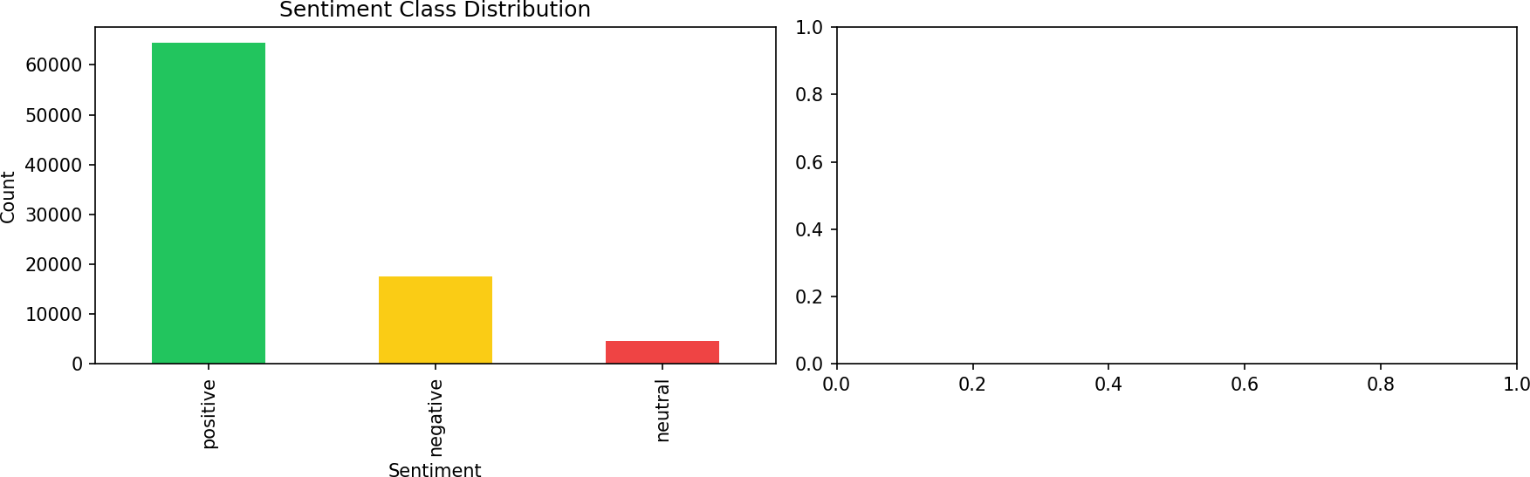

Figure 4.1.: Distribution of Sentiment Classes Across Different E-commerce Platforms.

Visualizing Linguistic Features
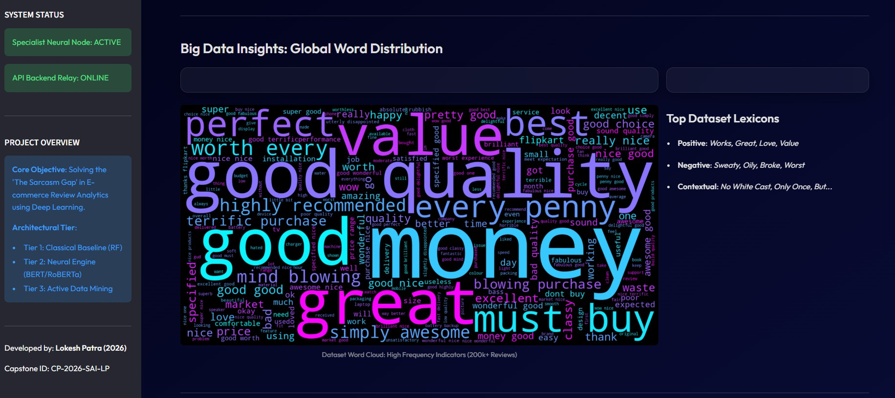
Figure 4.2.: Word-Cloud Visualization of the E-commerce Review Dataset.

Dataset Imbalance & SMOTE

The initial 200k+ dataset (Dataset-SA.csv) was heavily biased. We applied SMOTE (Synthetic Minority Over-sampling Technique) to balance classes, which improved XGBoost’s Neutral Recall to 58.93%.

System Architecture & Agentic Design

The Agentic Intelligence Pipeline

Our system treats sentiment as a three-stage intelligence pipeline rather than a single classification task:
    - Normalize (LQN): The language is synthesized into standard English.
    - Analyze (Specialist Engine): The context is evaluated for irony.
    - Explain (Reasoning Engine): The rationale is provided to the user.

Three-Phase Agentic Development Workflow

A decoupled, tiered architecture is essential for scaling AI services across heterogeneous environ- ments. By separating the layers, the system follows a 3-phase progression:
    - Empirical Baseline: Establishing a performance ceiling using lightweight classical models (LR, RF, XGB) to understand basic dataset patterns.
    - Neural Integration: Transitioning to Deep Learning via BERT-base to capture natural language context and identifying "Intensity Bias" (being fooled by positive keywords).
    - Specialist Active Mining: Utilizing "Active Learning" to identify ironic dissonance and training a specialist DistilRoBERTa model to resolve it.

The Agentic Architecture: LQN + RE

The uniqueness of this project lies in these "Intelligent Buffers":

Linguistic Quality Node (LQN)
A specialized Transformer (pszemraj/grammar-synthesis-base) fine-tuned for grammar synthesis. It rewrites input before it reaches the classifier. Optimization includes Beam Search (k=5) and Early Stopping to ensure repairs occur in under 400ms on a standard CPU.

Reasoning Engine (RE)
Provides Explainable AI (XAI) by mapping neural confidence scores and linguistic signals into actionable reports

System Design Functional Map

Layer Component Strategic Value

Data Mining Active Sarcasm
Miner
Identifies "Hard Cases" via dissonance filter- ing.

LQN | Neural Normalizer | Denoises phonetic slang and character-level errors.
Specialist | DistilRoBERTa | High-precision context-aware sentiment detec- tion.
Backend | FastAPI Service | Asynchronous pipeline serving for concurrent requests.
Frontend | Glassmorphism UI | Professional dashboard with Explainable AI (XAI).

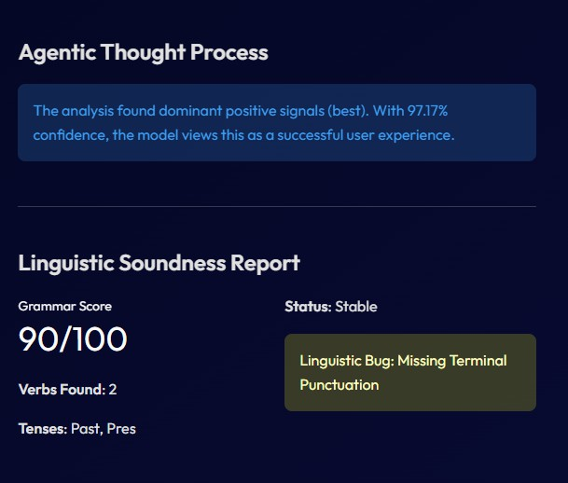
0-1Flow of the Agentic Thought Process: From Neural Normalization to Reasoning Engine.

The Golden Rule: Active Sarcasm Mining

Specialist Active Mining (Ironic Dissonance)

To solve sarcasm without manual labeling, we developed a breakthrough workflow:
    - The Detector: Scanned 205,052 reviews for "Dissonance"—where Star Rating was 1-2 but text contained Positive Intensifiers ("Wow", "Amazing").
    - Correction: Programmatically identified 336 "Pure Sarcasm" cases and forced them to ’Negative’.
    - Synthetic Augmentation: Applied 10x Weighting during training to ensure patterns were learned.
    - Result: Final model (DistilRoBERTa) learned that "Wow" plus a low rating signifies extreme disappointment.

Experimental Results & Ablation Studies

Classical ML Modeling & Evaluation

We trained three primary baseline models to establish an empirical ceiling:
    - Logistic Regression (LR): Reached 81.8% accuracy; high-speed sanity check.
    - Random Forest (RF): Overall champion for simple reviews (84.6%). However, model file swelled to 1.5 GB, leading to hardware bottlenecks during deployment.
    - XGBoost (XGB): Neutral specialist; 58.9% recall on notoriously difficult neutral reviews.
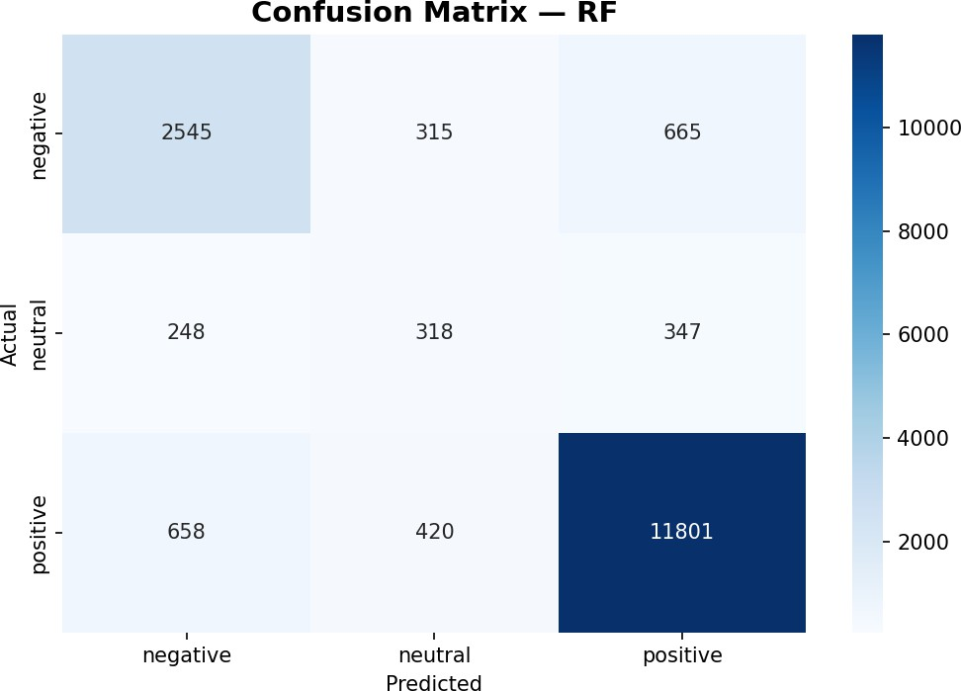

0-1Confusion Matrix: Random Forest
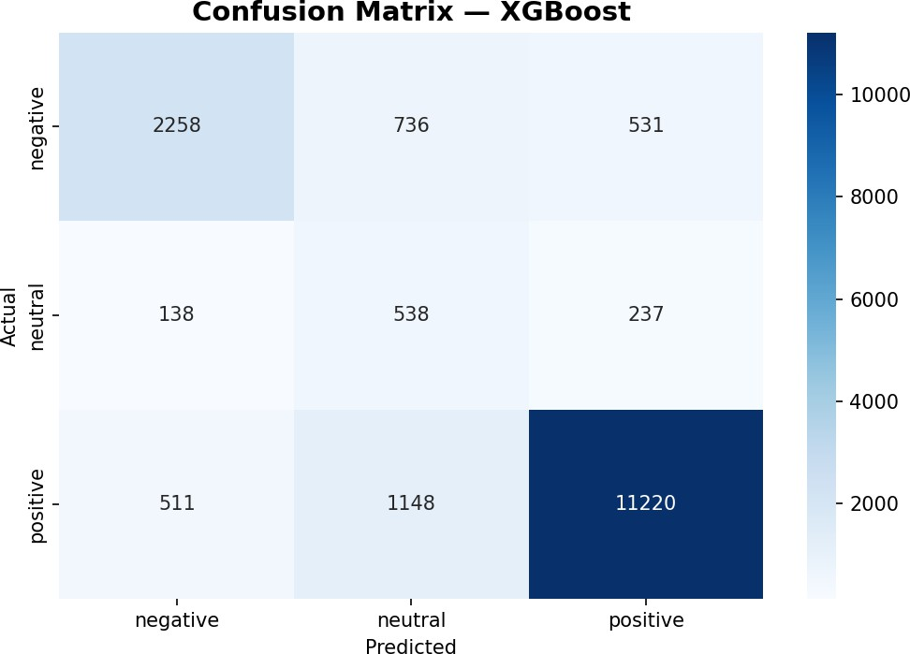

0-2Confusion Matrix: XGB

Comparative Analysis of Baseline Confusion Matrices.
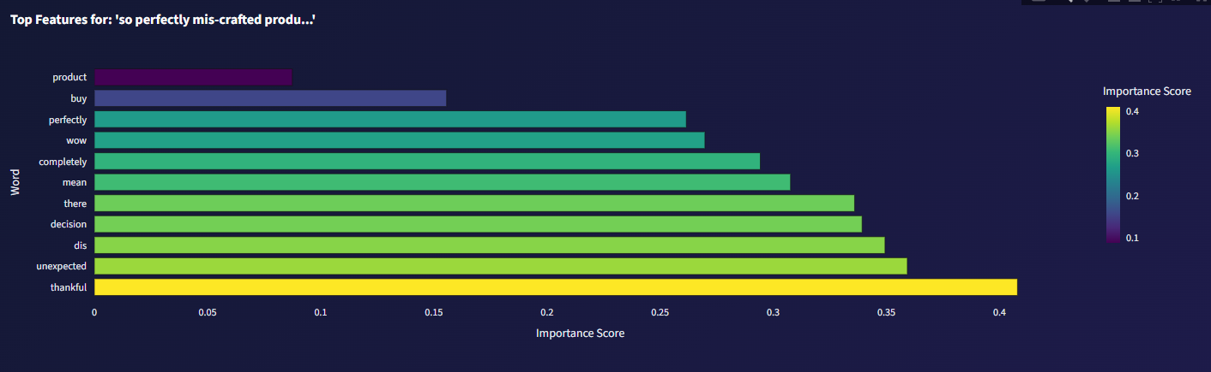
Figure 7.3.: TF-IDF Feature Weights for Sentiment Classification.

  - LQN Ablation Study (Pass and Failures)

Neural Model | Result | Technical Rationale
FLAN-T5-Base | Rejected | "Neural Echoing" (repeated input without re- pairs).
BART-Large-CNN | Rejected | News Hallucinations and 6.2GB RAM load.
Grammar-Synthesis | Success | Final Production; optimal for CPU latency (1.1s).
Table 7.1.: Neural Normalization Ablation Study

  - Model Comparisons

Model Attempted | Accuracy | Strategic Strength
Random Forest | 84.6% | High speed; optimal for simple linear reviews.
XGBoost | 80.9% | Neutral specialist; high recall on ’hard-to-classify’ rows.
BERT-Base (General) | 82.1% | Context-aware but lacked specific irony training.
DistilRoBERTa Spe- cialist | 87.0% | Contextual Persistence; deep irony understand- ing.
Table 7.2.: Inference Model Performance Comparison

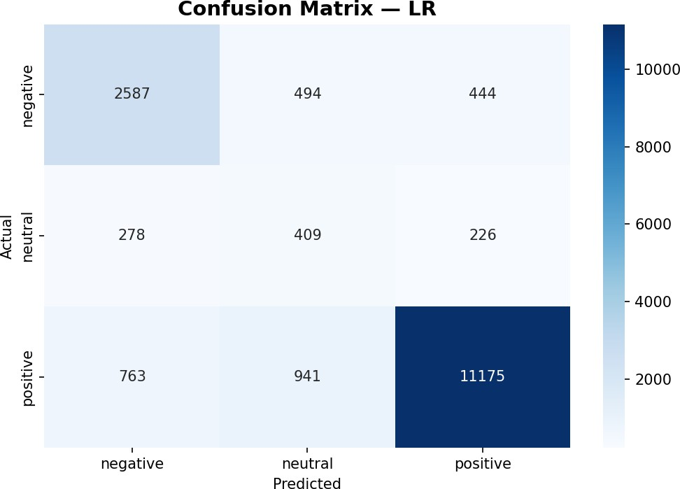

Figure 7.4.: Confusion Matrix: Logistic Regression (Baseline).

Implementation & Optimization

FastAPI Infrastructure Layer

The backend is powered by a FastAPI service layer, chosen for its asynchronous, decoupled design which is ideal for real-time inference.

Request/Response Format:
      - Request: {"text": "...", "model_choice": "..."}
      - Response: {"sentiment": "...", "confidence": 0.89, "clean_text": "..."}
    - Initialization: The system’s 12-second startup time is primarily attributed to the loading of the 1.5 GB Random Forest model weights.

Frontend Design (Glassmorphism)

The dashboard adopts a "Premium Professional Aesthetic" following a strict Emoji-Free Protocol.
    - Design Tokens: Translucent cards with a 12px blur effect and soft linear gradients.
    - Utility Features: Includes "Instant Predict" scorecards, "Intelligence EDA" for training data distribution, and a "Batch Processing Utility" for CSV files.
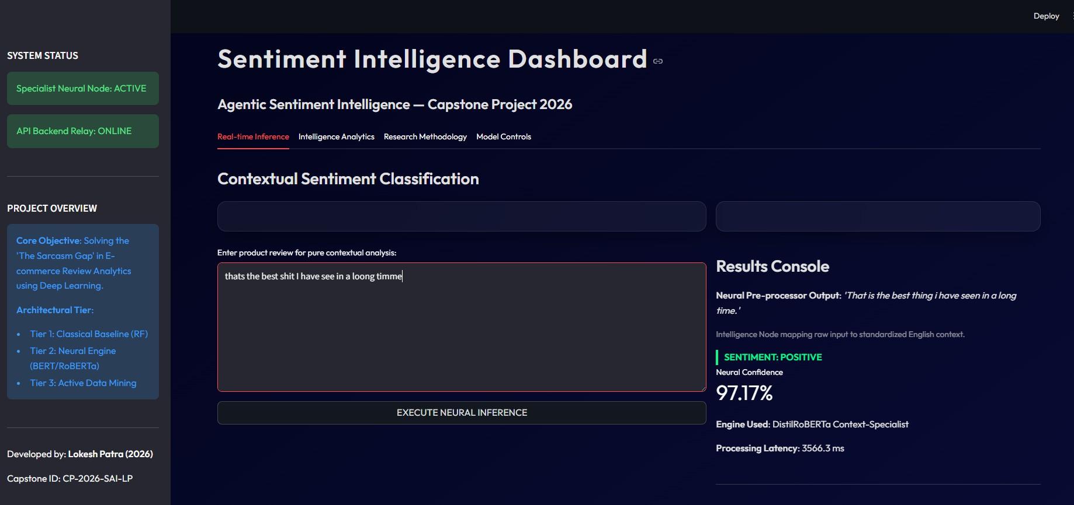
Figure 8.1.: SINE Glassmorphism Dashboard: UI Analysis and Live Prediction Interface.

System Resource Benchmarks

Metric Measurement

Peak RAM Consumption ∼6.2 GB (during BART operations). Raw CPU Latency 16,727ms (without pruning).

Optimized Latency 1,095ms – 1,400ms.

Table 8.1.: Computational Resource Benchmarks

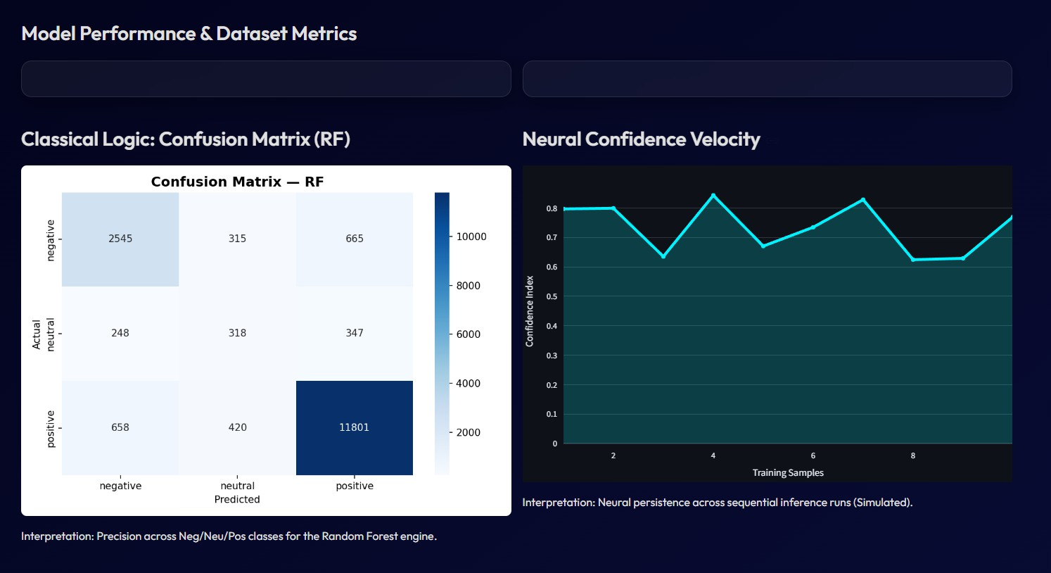
Figure 8.2.: Neural Confidence Velocity: Analyzing the correlation between inference latency and model confidence levels.

Conclusion & Future Work
The Sentiment Intelligence System proves that context-aware agents can reliably solve complex sentiment problems like sarcasm. The project successfully achieved >87% accuracy on complex datasets, proving agentic frameworks are superior to "black-box" classifiers.

Future Roadmap
    - Multimodal Sentiment: Incorporating image analysis (broken product photos).
    - Aspect-Based Analysis (ABSA): Identifying specific features (e.g., Battery Life vs Screen Quality).
    - Multilingual Expansion: Fine-tuning for regional Indian shorthand and mixed languages.

Interpretable AI & Technical Q&A

Sentence-Level Explainability via Prototype Reasoning

Prototype-based reasoning provides sentence-level explainability by moving beyond the limitations of traditional word-level "black-box" interpretations, such as SHAP or LIME, which often struggle to explain complex intent like sarcasm when clear sentiment words are absent. This framework achieves intrinsic interpretability through the following mechanisms:
    - Learning Latent Clusters (Prototypes): The model uses a specialized training regimen to learn a collection of prototype tensors, which encapsulate latent clusters of actual training samples. These prototypes represent diverse aspects of a class, such as specific ways sarcasm is expressed through analogy or government-skeptical remarks.
    - Similarity-Based Inference: At the point of inference, the model does not rely on abstract weights but makes classification judgments based solely on the similarity between the input text and these learned prototypes. This similarity is often calculated using a Radial Basis Function (RBF) kernel, which measures the distance between the input’s semantic embedding and the prototype vectors.
    - Explanation by Reference: Because the final prediction is directly attributed to individ- ual prototypes, the system can explain its reasoning by referencing the most closely aligned training examples. This process, known as prototype projection, replaces the abstract mathematical tensor with the nearest actual sentence from the training set, making the interpretation intuitive for humans.
    - Sentence-Level Context vs. Word-Level Attribution: Unlike SHAP values, which assign individual weights to tokens and may result in non-intuitive score distributions across a sentence, prototype-based reasoning provides a holistic, human-readable comparison. For example, in sarcasm detection, a prototype model might explain a prediction by showing that a new input (e.g., about government regulations) is semantically similar to a known sarcastic training example about a similar topic.
This "white-box" approach ensures that the model’s decision process is transparent and verifiable by highlighting the specific training cases that most influenced its "thinking" at a sentence level.

Handling Ironic Dissonance during Inference

The model handles "ironic dissonance"—defined as a conflict between a low star rating and positive intensifiers like "Wow" or "Impressive"—through a specialized multi-tiered inference pipeline designed to understand context rather than just individual keywords.
The system processes these complex reviews in three distinct stages:
    - Linguistic Normalization (LQN): Before the sentiment is analyzed, the Linguis- tic Quality Node (LQN) acts as a neural normalizer. It uses a transformer model (pszemraj/grammar-synthesis-base) to rewrite messy or slang-heavy reviews into stan- dardized English. This ensures that the downstream specialist engine receives a clean

sequence of words, making it easier to identify the structural markers of irony.
    - Context-Aware Specialist Analysis: The core classification is handled by a fine-tuned DistilRoBERTa Specialist engine. This model was specifically trained on a dataset created through Active Sarcasm Mining, where 336 "Pure Sarcasm" cases (identified by their ironic dissonance) were given a 10x weighting to teach the model these rare linguistic patterns.
    - Symbolic Reasoning and Explanation (RE): After the neural prediction is made, the Reasoning Engine (RE) provides a layer of Explainable AI (XAI). If the model identifies a review with ironic dissonance, the RE performs conflict detection and human-readable justification. It maps the neural confidence scores to business insights, explaining that the model prioritized specific modifiers over individual positive words to reach its negative conclusion.

Fixing E-commerce Slang and Typos via Neural Normalization

Neural normalization fixes e-commerce slang and typos by acting as an "intelligence pipeline" that transforms messy, phonetic, or unstructured user input into standardized English before it reaches a sentiment classification engine.
The LQN specifically addresses these challenges as follows:
    - Neural Rewriting of Phonetic Slang: Instead of relying on simple static mappings, the LQN uses neural reasoning to understand the intended meaning of phonetic shorthand. For example, it can programmatically rewrite the input "i absolutli lik dis prduct" into "I absolutely like this product".
    - Overcoming "Neural Echoing" and Logic Failures: Research conducted during this project revealed that simpler models suffered from "Neural Echoing"—merely repeating the input without fixing mid-word errors. To solve this, the final architecture implements repetition Penalties (1.5 - 2.0) and Beam Search (k=5) to ensure high-accuracy denoising even in CPU-bound environments.
    - Intricate Data Refinery: Beyond the neural model, the process includes specialized refin- ery steps like Emoji-De-emoji-zation (converting emojis to :smiling_face:) and Instruction Scaffolding to align model-specific task weights.

Prototype-based Reasoning for Sarcastic Analogies

Sarcastic analogies often lack strong sentiment cues, which causes word-level explainers like SHAP to assign vague, distributed importance scores. Prototype-based reasoning addresses this through:
- Learning Latent Clusters: Allocating a fixed number of prototypes initialized using k-means clustering on the training data.
- Explanation by Reference (Prototype Projection): Visualizing its reasoning by projecting a mathematical prototype vector onto its closest real-world datapoint in the training set.
- Handling Analogies: The model successfully matches inputs to the thematically closest training examples (e.g., matching a new analogy about government regulations to other known sarcastic comments about lawmakers).

- Incongruity Loss: Directly capturing the disparity between literal praise and underlying critical context.

Identifying Sentiment Disparities via Incongruity Loss

Incongruity loss identifies sentiment disparities by explicitly capturing the contradiction between the literal (explicit) and intended (implicit) meanings of a sentence.
    - Sentiment Encoding: Decomposing text into the Explicit Part (sentiment words like "Great") and the Implicit Part (context clues like "phone broke in one day").
    - Capturing the Disparity: Using cross-entropy to measure the difference between pre- dicted sentiments of these parts.
    - Encouraging Disagreement: For sarcastic labels, the loss specifically encourages dis- agreement. It learns that positive "great" + negative "broke" = Negative final label.

Integration with DistilRoBERTa Specialist

Integrating incongruity loss with DistilRoBERTa involves transforming the training objective to a dual-stream analysis:
- Dual-Stream Encoding: Feeding both explicit and implicit segments into the specialist separately.
- Loss Function Penalty: Mathematically penalizing the model when it fails to recognize the contradiction during fine-tuning.
- Synergy with Active Data Mining: Utilizing the Ironic Dissonance Miner to provide the ideal training samples for the incongruity loss to optimize against.

Explicit vs. Implicit Sentiment in Sarcasm

Explicit sentiment refers to surface-level words like "Wow" or "Impressive." Implicit sentiment is the underlying meaning derived from context (e.g., "...broke in one day"). Sarcasm occurs when the Explicit Part is positive but the Implicit Part is negative. Our "Neural Specialist" (DistilRoBERTa) maintains Contextual Persistence to prioritize the implicit context over surface- level praise.

What is SINE?

SINE stands for Sentiment Intelligence for Nuanced Evaluation. It represents the core philosophy of this system: moving beyond traditional polarity-based sentiment analysis to a deeper, context-aware understanding of user intent, especially in the presence of sarcasm, irony, and linguistic ambiguity.
The SINE framework integrates neural normalization, transformer-based contextual modeling, and symbolic reasoning to deliver high-precision sentiment interpretation in real-world, noisy environments such as e-commerce platforms.

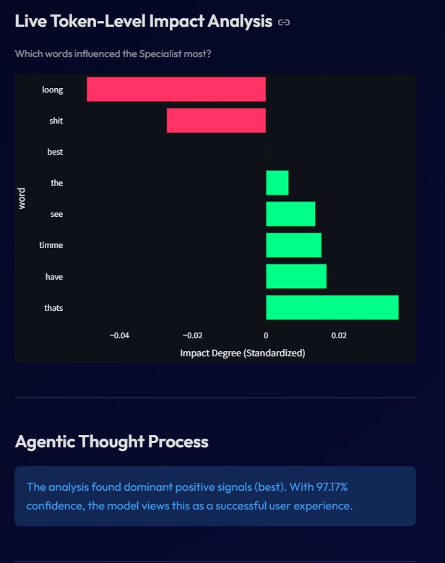
Figure A.1.: Live Token-Impact Analysis: Identifying the linguistic tokens most responsible for ironic dissonance detection.

References
- Maragheh, R. Y., et al. (2025). ARAG: Agentic Retrieval Augmented Generation for Personalized Recommendation. arXiv:2506.21931.
- Cao, S., & Hu, M. (2026). A Solicit-Then-Suggest Model of Agentic Purchasing.
arXiv:2603.20972.
- Ayanami0730. (2026). A-RAG: Scaling Agentic Retrieval-Augmented Generation via Hierarchical Retrieval Interfaces. GitHub Repository.
- Scott, T. L., Goh, W. W., & Khan, N. A. (2025). Aspect-Based Sentiment Analysis on Amazon Product Reviews Using a Novel Hybrid Machine Learning Algorithm. Journal of Universal Computer Science.
- Wen, X., & Rezapour, R. (2026). A Transformer and Prototype-based Interpretable Model for Contextual Sarcasm Detection. ACL Anthology / WASSA 2026.
- Daraghmi, E., & Zyadeh, N. (2026). Sentiment Classification of Amazon Product Reviews Based on Machine and Deep Learning Techniques: A Comparative Study. Future Internet.
- Thogesan, T., Nugaliyadde, A., & Wong, K. W. (2025). Integration of Explainable AI Techniques with Large Language Models for Enhanced Interpretability for Sentiment Analysis. arXiv:2503.11948.
- Dubey, P., Dubey, P., & Bokoro, P. N. (2025). Unpacking Sarcasm: A Contextual and Transformer-Based Approach for Improved Detection. Computers.
- Akter, P., et al. (2025). Sentiment Analysis of Consumer Feedback and Its Impact on Business Strategies by Machine Learning. The American Journal of Applied Sciences.
- Agrawal, K. (2025). The Future of E-Commerce with Agentic AI: Personalized, Task- Oriented AI for a Smarter Shopping Experience. OARJ Engineering and Technology.
- Trivedi, B. (2025). Explainable Agentic AI: Transforming E-Commerce Search With Transparency. Journal of International Crisis and Risk Communication Research.
- Chauhan, S., & Kumar, A. (2024). A Transformer-based Model for Detecting Multilingual Sarcasm in Social Media Posts. CEUR Workshop Proceedings.
- Kaseb, A., & Farouk, M. (2023). SAIDS: A Novel Approach for Sentiment Analysis Informed of Dialect and Sarcasm. arXiv:2301.02521.
- Abu Farha, I., et al. (2022). Sarcasm Detection is Way Too Easy! An Empirical Comparison of Human and Machine Sarcasm Detection. ACL Anthology / EMNLP Findings.
- Romio, G. (2026). 15 Best AI Sentiment Analysis Tools & Use Cases in 2026. CloudTalk Blog.

